RabbitMQ:
RabbitMQ is an open source message broker software that implements the Advanced Message Queuing Protocol (AMQP).It is a free message broker which follows the Advanced Message Queuing Protocol (AMQP). This AMQP is the working standards for the high performance enterprice messaging. AMQP’s are widely accepted open source standards for distributing and transfering messages from source to destination machine. The RabbitMQ server is a robust and scalable implementation of an AMQP broker. rabbitmqctl is a command line tool for managing a RabbitMQ broker. It performs all actions by connecting to one of the broker's nodes. Diagnostic information is displayed if the broker was not running, could not be reached, or rejected the connection due to mismatching Erlang cookies.

AMQP standardizes messaging using Producers, Broker and Consumers. Messaging increases loose coupling and scalability.
How RabbitMQ Works?
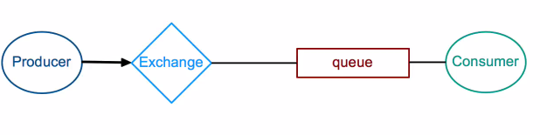
We have producer and consumer between them life secure. The producer sends the message to the queue. However producer never uses the queues directly instead producer uses an Exchange. Publication of message means that the producer send the message to the Exchange and the Exchange forward the message to the queue. Consuming of message means that the consumer picks up a message from the queue and consumes it. In Exchange wont make much sense if we have only one queue.
However in a complex applications, we can have multiple queues followed by multiple consumers. Inorder to Exchange the message to queues there is binding or binding key. Inorder to send the message from producer to Exchange requires routing key. How the Exchange compares two routing keys on the type of Exchange. Fanout simply ignores the routen queue and sends the message to all the queues knows about. The Direct Exchange sends the messages to the queues whether the routing key is exactly same as the binding key.For example routing key = binding key. The Topic Exchange alots of partial match keys. For example routing key = red and binding key = red.green. Finally, the Header Exchange uses the message data or message header instead of routing key. In RabbitMQ exists one special kind of Exchange known as Default(nameless) Exchange. This Exchange compares the routing key with the queue name and not the binding key.
Producer emits messages to Exchange.
Consumer receives messages from Queue.
Binding connects an Exchange with a queue using binding key.
Exchage compares routing key with binding key.
Messages distribution depends on Exchage type.
Exchage types: fanout, direct, topic and headers.
Default (nameless) Exchage: It is special Exchage created by RabbitMQ. It compares routing key with queue name. It sends the message directly to the queues.
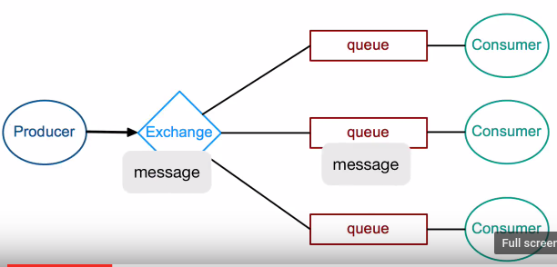

How to Install RabbitMQ in Ubuntu

1. Before installing RabbitMQ we have to update our software.
sudo apt-get update
2. Before installing RabbitMQ we have to upgrade the system. To download and install the
packages which is relevant to the operating system.
sudo apt-get upgrade
3. Now we can download and install the main dependencies packages for the RabbitMQ i.e,
erlang
sudo apt-get install erlang
4. Now, we can download and install the RabbitMQ Server
sudo apt-get install rabbitmq-server
5. Now, we can enable the RabbitMQ services
sudo systemctl enable rabbitmq-server
6. Now, we can start the RabbitMQ services
sudo systemctl start rabbitmq-server
7. Now, we can check the status of RabbitMQ server
sudo systemctl status rabbitmq-server
8. Now, we can enable the RabbitMQ management console
sudo rabbitmq-plugins enable rabbitmq_management
9. Now, you can add the admin user to RabbitMQ
sudo rabbitmqctl add_user username password
ex: sudo rabbitmqctl add_user hduser rockstar
10. Now, we need to add the tags
sudo rabbitmqctl set_user_tags username administrator
ex: sudo rabbitmqctl set_user_tags hduser administrator
11. Now, we can set the permissions for the admin user
sudo rabbitmqctl set_permissions -p / username ".*" ".*" ".*"
ex: sudo rabbitmqctl set_permissions -p / hduser ".*" ".*" ".*"
12. Now, you can open the browser and type the ip address in url. Make sure that ip address
should be of our local machine. In order to check the ipaddress in linux type the
command known as ifconfig
192.168.7.153:15672
ex: http://192.168.1.2:15672/
13. Now, you can login to the RabbitMQ by providing username and password in browser.

Start and Stop the RabbitMQ Server

1. Log in as the root user or otherwise use sudo in front of commands and open a terminal window.
2. To be in rabbitmq_server
rabbitmq
3. Enable the rabbitmq_management
sudo rabbitmq-plugins enable rabbitmq_management
4. Disable the rabbitmq_management
sudo rabbitmq-plugins disable rabbitmq_management
5. Start the RabbitMQ server using the rabbitmq-server command, passing it the start
option. For example:
sudo rabbitmq-server start
The RabbitMQ server process runs as the rabbitmq user, which is non-interactive.
6. Inorder to restart the rabbitmq-server
sudo service rabbitmq-server restart
7. Accessing the RabbitMQ Server through GUI
Now, you can open the browser and type the ip address in url. Make sure that ip address
should be of our local machine. In order to check the ipaddress in linux type the command
known as ifconfig
192.168.7.153:15672
ex: http://192.168.1.2:15672/

8. Now, you can login to the RabbitMQ by providing username and password in browser.
Username: guest
Password: guest
9. Inorder to stop the rabbitmq-server
sudo service rabbitmq-server stop
https://github.com/rabbitmq

